**BLOOD CONNECT**

**~Save Your Soul!**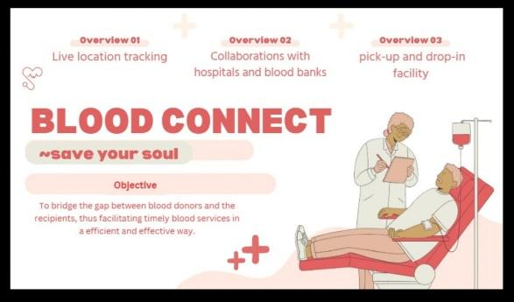

**TEAM MEMBERS:-**

**S-HE CODERS**

G. V. D. Hasini

G. Yogitha Jyothirmai

K. Poojitha

P. Sai Babu

-----------------------------------------------------------------------------------------------

**Keywords:** Blood shortage, Healthcare systems, Blood donation, Donor-recipient gap, Emergency medical needs, public awareness, Logistical challenges, Real-time communication, Blood storage and transportation, Voluntary blood donation, Healthcare infrastructure, Community involvement, Medical emergencies, Blood donor networks, Preventable deaths.

**INTRODUCTION**

In response to the critical challenges surrounding blood shortages and inefficient donor-recipient connectivity, a structured and responsive platform is essential. Our solution envisions a comprehensive system that facilitates faster, more reliable communication between individuals in need of blood and potential donors. By leveraging real-time tracking, emergency prioritization, and localized matching, the solution aims to ensure that life-saving blood donations are delivered efficiently and safely, especially during urgent situations.

The platform is designed to not only connect donors and recipients but also to support individuals who face barriers in reaching donation centres. Through features such as transportation assistance and home collection services, the system seeks to make blood donation accessible to a wider population. Additionally, the platform emphasizes building a strong, consistent donor community by encouraging regular participation and sharing impactful stories to inspire new donors.

Data security, user privacy, and medical safety standards are fundamental to the solution's design, ensuring that all interactions and transactions are conducted with transparency and trust. By integrating technology with a humanitarian mission, the platform aspires to transform blood donation into a seamless, community-driven process that can significantly reduce the gap between supply and demand.

Ultimately, the solution represents a step towards building a resilient, compassionate network that supports healthcare infrastructure and saves lives. Through organized connectivity, logistical support, and public engagement, it addresses the existing challenges in blood donation systems and works towards creating a healthier, more responsive society.

**PROBLEM STATEMENT**

Accessing blood donors during emergencies is often inefficient, leading to critical delays in lifesaving. When a patient or caretaker is in a need of blood during an emergency, they want a reliable and quick way to find donors with the required blood group nearby, so they can receive timely assistance without unnecessary delays.

**HOW THE PROBLEM CAN BE ARTICULATED?**

BLOOD CONNECT aims to solve this problem by creating a centralized platform that enables quick donor-recipient connections, live location tracking, and streamlined communication.

**The “How might we” Questions**

(a) How might we create a system to instantly connect blood recipients with nearby donors?

(b) How might we ensure that blood requests are communicated effectively and promptly?

(c) How might we enable live location tracking to make coordination faster and more efficient?

**BLOOD CONNECT + HOSPITAL SERVICES**

Creating a separate dashboard for hospitals to manage their blood availability within the BLOOD CONNECT app helps in various ways. When there is an unavailability of blood from the users of the app, recipients can look up to the available hospitals in their locality with the help of the app itself.

This involves building a secure, user-friendly interface that allows hospitals to register, update blood stock, and manage their inventory. Below is a step-by-step guide on how you can build this dashboard:

**Hospital Registration and Authentication:** To ensure only authorized hospitals can update their blood stock, you'll need a registration and authentication system.

**Hospital Registration Process:** Hospitals can sign up through the app by providing basic details such as: Hospital Name, Contact Information, Hospital Type (e.g., public, private), Location (address, GPS coordinates), Blood Bank Manager details (for further communication).

**Verification Process:** Hospitals need to be verified before they can access the dashboard. This could be done via: Email verification or Manual admin approval (if needed for additional security).

**Authentication**: After registration, hospitals should be able to log in using secure credentials (username and password, or email and password). Multi-factor authentication (MFA) is implemented for additional security.

**Technologies:** Firebase Authentication, JWT, OAuth for secure login and registration.

**VOLUNTARY DONATIONS, HOSPITAL’S ROLE IN IT**

Hospitals, not just take a step in the donations during blood requirement but also takes a part in storing the blood in the hospitals.

Voluntary blood donations are conducted via app even when there is no immediate need, and this collected blood will be stored in the integrated hospitals.

When neither ‘donor is available to donate’ nor ‘any hospital has required blood’ this feature helps in utilizing that stored blood by BLOOD CONNECT from the hospitals.

**HOW BLOOD IS STORED SAFELY IN HOSPITALS?**

Blood storage in hospitals requires strict temperature control and advanced technology to ensure its safety and usability for future needs. Red blood cells are stored at 1°C to 6°C in specialized blood bank refrigerators, platelets at 20°C to 24°C with constant agitation to prevent clotting, and plasma is frozen at -18°C or lower for long-term storage. To maintain these conditions, hospitals use blood bank management software (BBMS), IoT sensors, RFID tracking, and ultra-low freezers to monitor inventory and storage conditions in real time

Before storage, donated blood undergoes rigorous testing for infections, after which it is separated into components—red blood cells, plasma, and platelets—to maximize its usability. Each blood bag is labelled with barcodes and expiration dates, and periodic quality checks are conducted. Safe transport is ensured through cold chain monitoring, refrigerated transport units, and emergency supply networks that allow hospitals to share blood as needed.

**ENABLING AT-HOME BLOOD COLLECTION AND SAFE TRANSPORTATION**

To implement this feature, three key aspects need to be considered: transportation for donors, at-home blood collection, and safe blood transport to hospitals.

* **Donor Pickup Service-**

The app will allow donors to request a pickup if they cannot travel alone. A verified person (e.g., a trained volunteer or healthcare worker) will be assigned to pick up and drop off the donor at the hospital.

**Technology Used**: Ride Scheduling APIs (similar to Uber APIs) for assigning a pickup vehicle. GPS Tracking & Routing Systems (Google Maps API) to optimize travel.

* **At-Home Blood Collection Service-**

If a donor prefers to donate at home, a nurse or trained medical professional will accompany the assigned person. The blood will be drawn following strict medical protocols to ensure safety.

* **Safe Blood Transport from Home to Hospital-**

Blood must be transported under controlled temperature conditions to prevent spoilage. A blood transport kit with a portable blood storage unit will be attached to the bike/car.

**Technology Used:** Portable Blood Storage Coolers: Small, battery-operated refrigeration units that maintain 1°C to 6°C for red blood cells and frozen storage for plasma.IoT Sensors for temperature monitoring: Ensures real-time tracking of temperature conditions during transport. RFID / Barcode Scanning: Tracks blood movement and ensures it reaches the hospital efficiently.

This feature will help elderly donors, disabled individuals, or anyone unable to travel contribute to saving lives while ensuring blood remains in perfect condition for use.

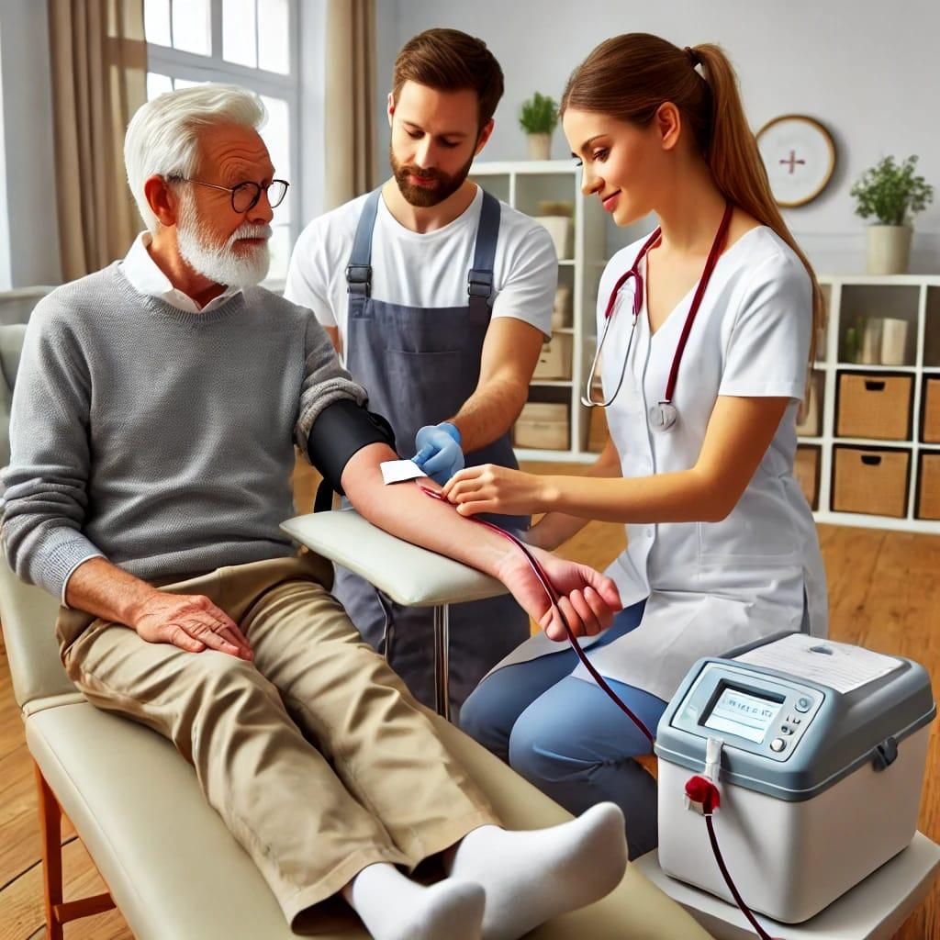

g

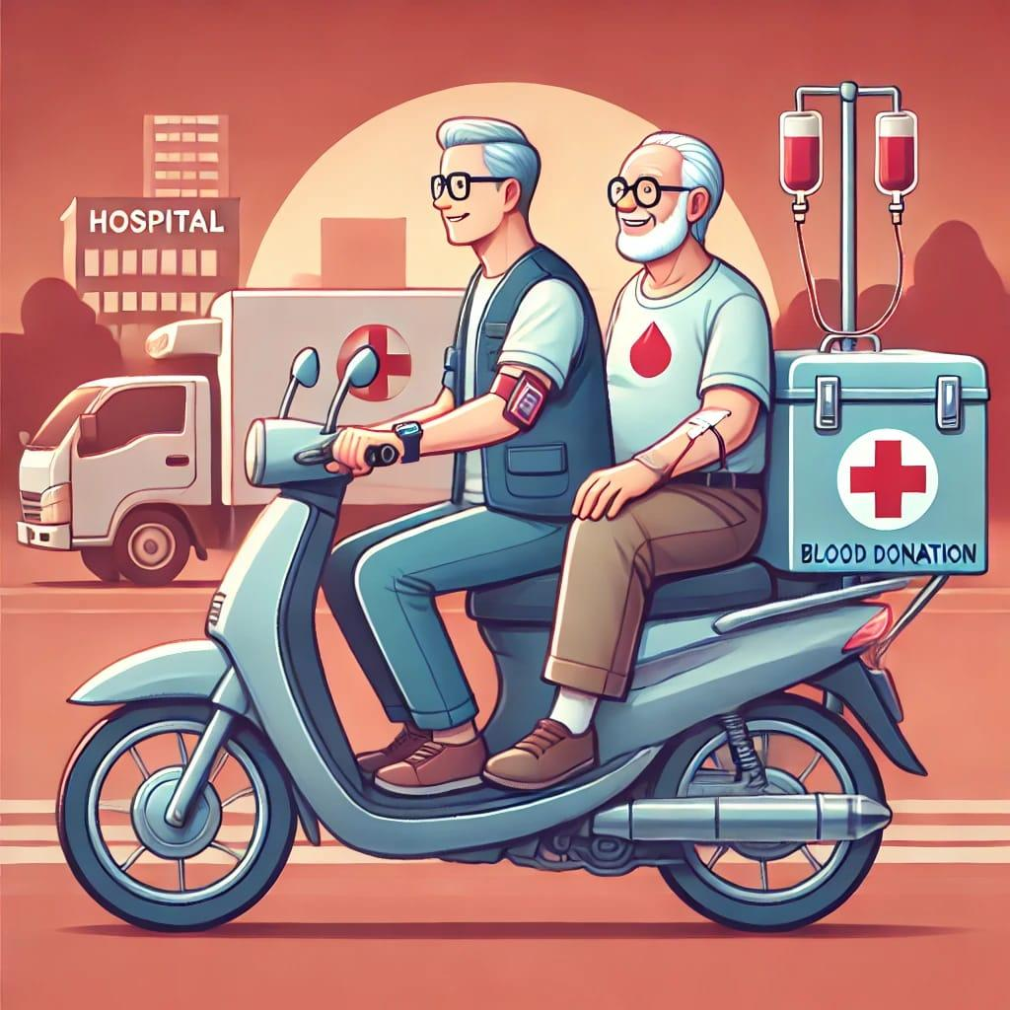

MADE-OUT HOME PAGE-

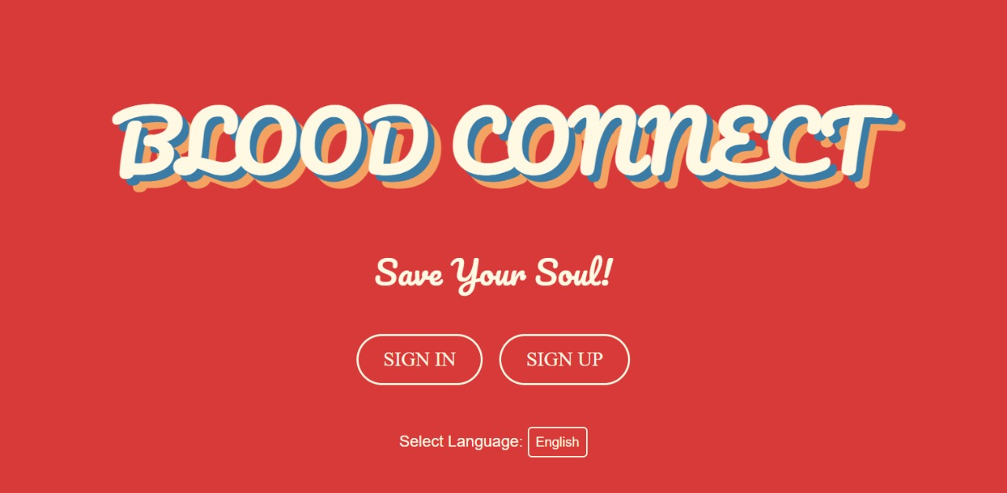

MADE-OUT SIGN IN PAGE-

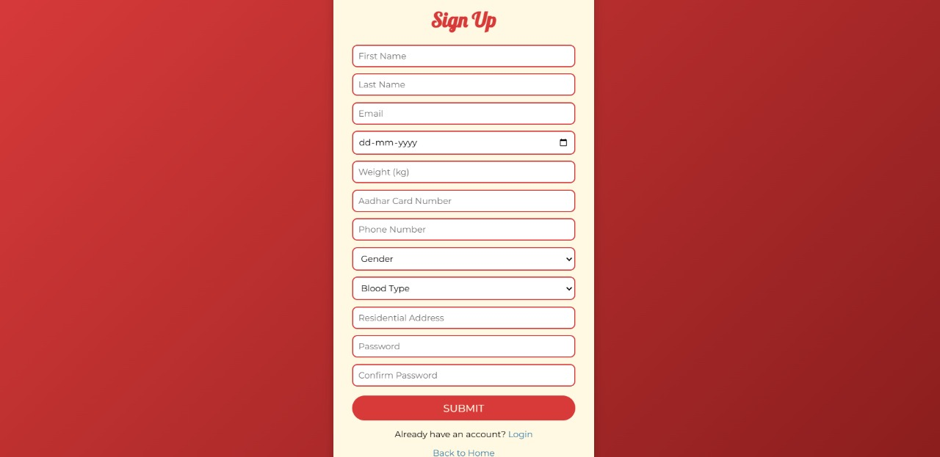

MADE-OUT LOGIN PAGE-

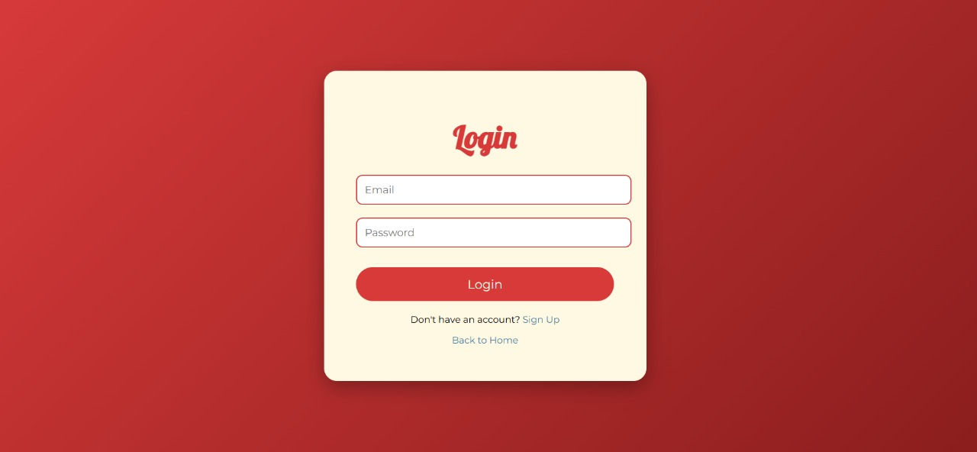

MADE-OUT MAIN PAGE-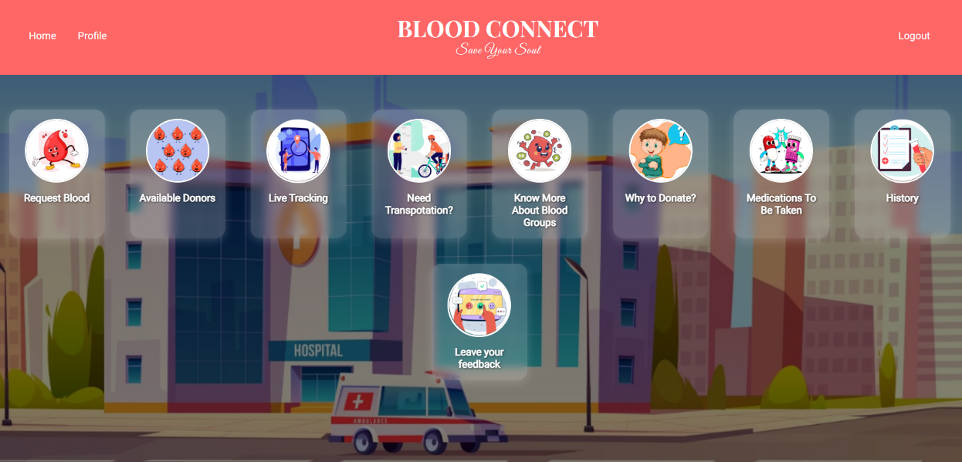

**A PROTOTYPE SIMILAR TO BLOOD CONNECT IS USED BY-**

**Healthcare Organizations:** Hospitals, clinics and blood banks use similar platforms to streamline blood donations.

**Non-Profit Organizations:** NGOs and charitable groups focused on healthcare and disaster relief use these prototypes to connect donors with recipients and organize blood donation drives.

**Government Health Departments:** Many governments implement similar systems to manage nationwide blood banks, track donations and respond to emergencies effectively.

**Tech Startups in Health Tech:** Health-focused startups often develop prototypes like this to address gaps in healthcare systems and provide innovative solutions for blood donation and management.

**Global Health Organizations:** Groups like the Red Cross or WHO use advanced systems for managing blood donations, particularly during crises or in under-resourced regions.

**Educational and Research Institutions:** Universities and research groups working on healthcare solutions might use such prototypes for projects or as part of their studies in public health or technology.

**Community-Based Blood Networks:** Organizations like the Red Cross and local blood banks maintain lists of regular donors who can be contacted when needed.

**Radio & Newspaper Announcements –** Before digital apps, urgent blood donation requests were often broadcasted through radio and newspapers.

**TECHNOLOGY USED IN BUILDING THE APP**

A wide range of technologies along with various API’s are used in building the BLOOD CONNECT’s interface and applications. They are as follows-

**Frontend:** Flutter that uses Dart language or the Android studio that uses Java/C++ is used for the purpose of app creation and development.

**Backend:** node.js, using JavaScript, TypeScript; Firebase Cloud Messaging (FCM) that uses Java, Python, JavaScript, C, Swift; Spring Boot using Java are used in the back-end development.

**Databases**: MySQL/PostgreSQL, MongoDB (no SQL type) are used for data storage purposes.

**Geographical services:** Google Maps API using JavaScript, Java, Python, C, Swift can be used to detect the live location or the Geocoding API can be used to find the address of the user based on latitude & longitude.

**IDEAS!**

**Notification system:** The notification system uses FCM that is., Firebase Cloud Messaging or the One Signal to send app notifications to the users. By filtering the algorithms, notifications can be sent to particular users.

**SMS services:** In case of unavailability of internet, SMS gateways can be used to send real-time SMS to the users, These SMS gateways uses languages like Twilio, JavaScript, Java, Python, C# for the development of this application.

**E-Mail:** In order to send e-mails to the users, email service API using node.js is useful.

**In-Chat/Calls:** Web RTC, FCM are used for real time communications through audio/video.

**Android Studio (Notification Manager Compact class**): This class helps in detecting the users who are ghosting the app notifications and text messages. In addition to this, it will end a pop-up to enable notifications when the user pens the app after a long time.

**OTP’s:** In case of sending OTP ‘s for any verification purposes, Firebase authentication can be used

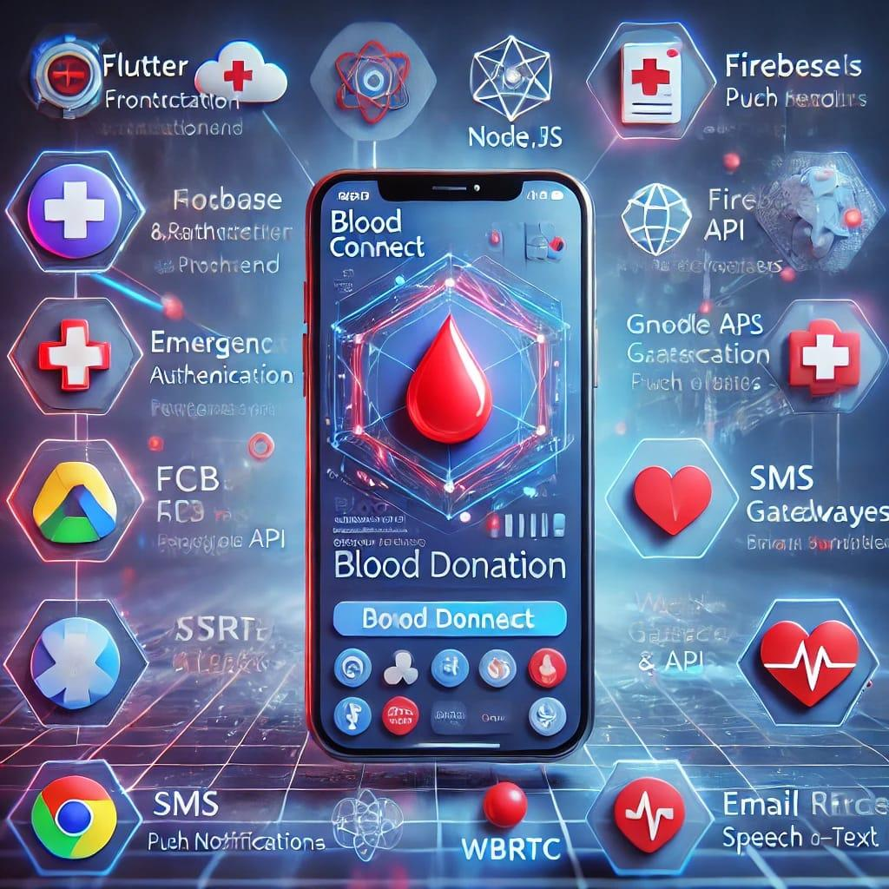

**STT:** The speech -to-text application helps people of different communications to utilise the app benefits by converting the input language voice to text. Or else, Google Cloud Translation can be used to detect the language and translate it.

**COLLABRATIONS**

Collaboration for BLOOD CONNECT can involve partnerships with various stakeholders to enhance the platform’s effectiveness and reach. Some of them are-

**Healthcare Institutions:** Partnership with hospitals, clinics and blood banks to ensure a reliable database of donors and recipients.

**Non-Governmental Organizations (NGOs):** Work with NGOs focused on health and emergency services to organize blood donation drives and awareness campaigns.

**Government Agencies:** Collaborate with public health departments to integrate the app with national blood donation programs. Seeking Government support for promoting the app and funding its development.

**Tech Companies:** Partnership with tech firms for app development, AI integration, and cloud-based data management. Also collaborating with GPS and mapping service providers for accurate location tracking.

**Educational Institutions:** Work with universities and colleges to encourage students to participate in blood donation campaigns.

Corporate Sponsors: Partnership with companies for funding and CSR (Corporate Social Responsibility) initiatives.

**Media and Influencers:** Collaborating with media outlets and social media influencers to spread awareness about the app and its mission. Also running campaigns to educate people about the importance of blood donation.

**International Organizations:** Partnership with global health organizations like the Red Cross or WHO for expertise, resources, and broader reach.

**INNOVATIVE OUTCOME?**

YES!

BLOOD CONNECT can be considered an innovative outcome because it enhances the traditional blood donation process with modern technology and unique features. While various blood donation platforms exist, BLOOD CONNECT introduces a real-time donor-recipient matching system, location-based notifications, and an emergency level indicator to prioritize urgent cases. These features ensure that recipients receive timely help while making the donation process seamless for donors. Additionally, its user-friendly interface and automated alerts improve accessibility, making it easier for people to participate in life-saving efforts. By integrating these innovations, BLOOD CONNECT not only fills gaps in existing systems but also creates a more efficient, responsive, and impactful solution for blood donation and emergency needs.

